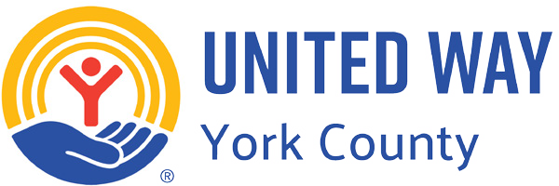

Dear [*Employee's Name*],

Congratulations on your new role at [*ABC Organization*]! We are thrilled to have you join our team.

At [*ABC Organization*], we take pride in being a Community Partner with United Way of York County (UWYC). Together, we have made a significant impact in our community by **giving back**, **getting involved**, and **taking action**. UWYC provides critical support to benefit hardworking households in York County through early childhood education, transportation, and financial wellness resources. Many of our friends, neighbors, and even members of our team have directly benefitted from UWYC programs. Please reach out if you or your family are in need of assistance.

We encourage you to embrace the spirit of giving that defines our organization. By making a gift to UWYC, you can help sustain these vital programs and services that help working families on their path to financial stability. Please complete the pledge form included to make your contribution today. **Every gift makes a difference!**

If you have any questions, feel free to reach out to [*Internal Contact's Name*] at [*Internal Contact's Email/Phone Number*].

Welcome to the [ABC Organization] family and thank you for being part of our mission to make a difference!

Best regards,

*[Contact]*

P.S. Donor networks like Emerging Leaders and Women United drive meaningful change in our local community. Consider “step up” options to join over time or go “all in” and make a commitment today. Plus, members enjoy exclusive events and can take advantage of built-in networking opportunities! See the flyer included for more details.